

Betting System
Process report

Group 10, SEP2Z-S16
Atanas Latinov (239 841)
Daniel Hamarik (239 857)
Stefan Alexiev (240 278)

Supervisors
Henrik Kronborg Pedersen
Jan Munch Pedersen

Table of Contents
Table of Contents 2
1. Group policy 3
2. Working Process 3
2.1 Sprints 7
3. Meetings 14
4. Project Result 15
5. Personal reflections 16

Table of figures
Figure 1. Betting system use case 4
Figure 2. Register to system description 5
Figure 3. Final version of the product backlog 6
Figure 4. Sprint 1 7
Figure 5. Sprint 2 8
Figure 6. Sprint 3 9
Figure 7. Sprint 4 9
Figure 8. Sprint 5 10
Figure 9. Sprint 6 11
Figure 10. Sprint 7 12
Figure 11. Sprint 8 12
Figure 12. Betting system burndown chart 15
Figure 13. Work size 16

1. Group policy

After initial discussions the group agreed to the following obligations and considerations:

All members created and decided to follow these rules:

1) I agree to meet up on a regular basis.
2) The time and place of meetings shall be agreed on by all group members.
3) If I am not able to come to a group meeting, I will contact other group members.
4) Stories are planned before their inclusion and execution in sprints.
5) We will spread the work equally between everybody.
6) I have to finish the work I am allotted to do on time and upload it to Dropbox.
7) I will communicate with others only in English.
8) If I get an idea how to do something differently, I will present it to the others.
9) I will be an active member of the group in all aspects.
10) I will write my code very clearly and understandably for others.
11) If I do not understand something, I will ask other members for help.
12) I will help others with problems in assignments.
13) I will understand the parts of the code that the other team members wrote.
14) I have the freedom to work on a task of my choice.
15) I will prepare a small revision of what I did and present it to the others during daily stand-ups.
16) If I am not satisfied with something, I will share it with my team members and work towards a solution together.

2. Working Process
The initial stage of every project that can be called successful, is the creation of a plan that separates the work in stages, hence providing the possibility for agile development. By following the process framework for agile software development Unified Process, we adopted a flexible strategy that provides us with four clearly distinguished phases in which we can focus on every aspect of the system we are building. For managing the software development part, we are using the
SCRUM Framework. In combination, these two strategies provide a well-organized scheme that enable us to push every facet of the project while doing time boxed iterations.

During the Inception phase we outlined the goals of the system. In the its course, the team discussed and agreed upon the main features that the program should provide as well as the delimitations and functionalities that the team knew that could not be implemented for the given timeframe. On a technical level, we used a class diagram that would give us an overview of the classes, how they are connected as well as the scope of the system as a whole.
After determining the main activities that the user could do, we included them in a Use case diagram, which contained a detailed description of every main action the user could go through. The following image is the use case diagram and a use case description for the first action:

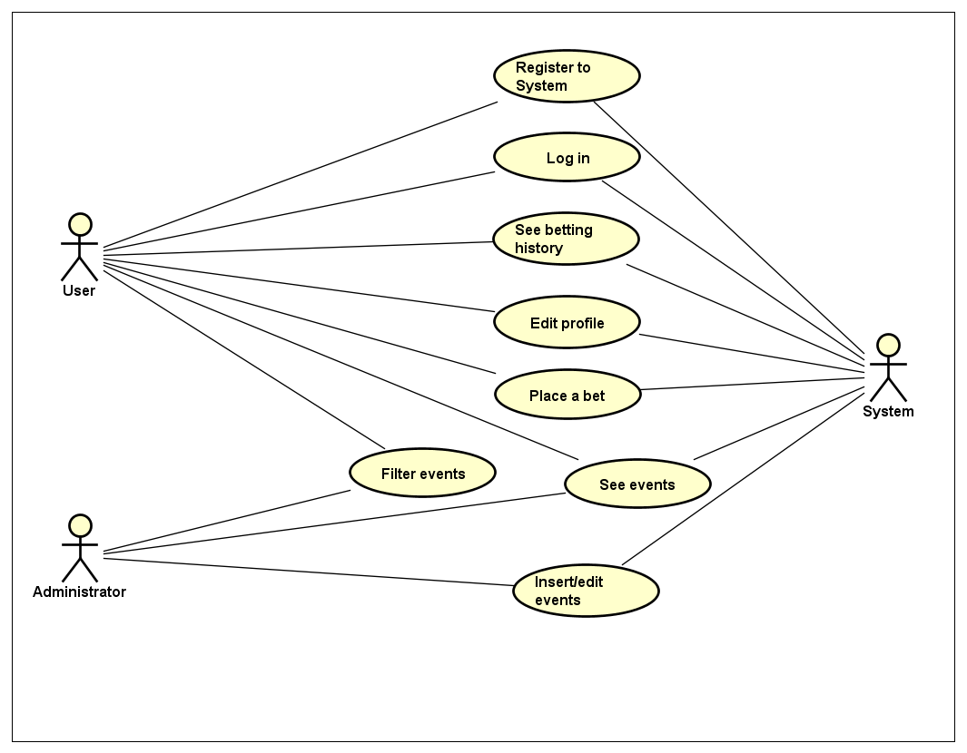
Figure 1. Betting system use case

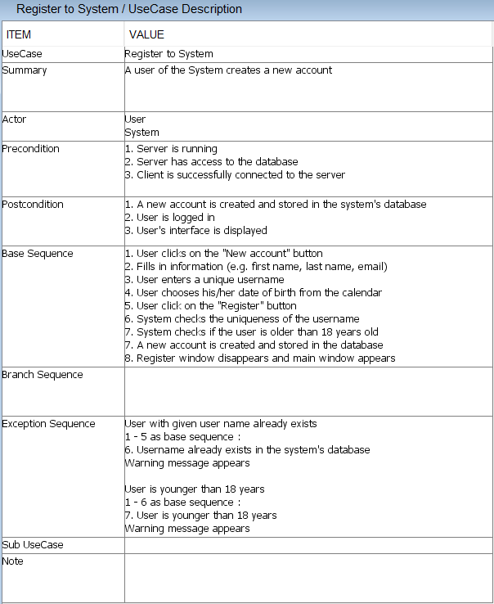
Figure 2. Register to system description

Another very useful tool for clarification of the possible action sequences is the activity diagram. We created such diagrams for every sequence of activities that the system provides. During the course of development, they turned out to be a great reference material, especially for the user interface design, since they helped us visualize the connection between the frames and other components.
After we outlined the main functions of the system, we moved on to the next UP phase – Elaboration. In the initial steps of this stage we started creating our product backlog. This main SCRUM artefact proved to be extremely useful as it was a reference list of all the functionality, desired in the product. This was the predominant way for us as a team to identify features in the form of user stories, which are short, simple descriptions of the desired functionality told from our perspective. The backlog also helped us identify the main risks from a programming and design standpoint. In our case, those proved to be the creation of the relational database, as well as its integration within our system. Another aspect, that we considered to be a challenge, was the Client-Server connection and the necessary architectural changes we had to consider.
What followed after identifying the larger tasks and prioritizing them in the list was to determine what had to be done in order for them to be implemented and fully functioning. During this process, we used the activity diagrams, coupled with the use case diagram and the use case diagram descriptions, as reference points from which we extracted the smaller tasks that had to be accomplished. The image below presents the product backlog. We would also like to acknowledge the fact that the backlog underwent several changes during the development process. This is due to the agile nature of the software development frameworks and their strategies that we have adopted for the current project.

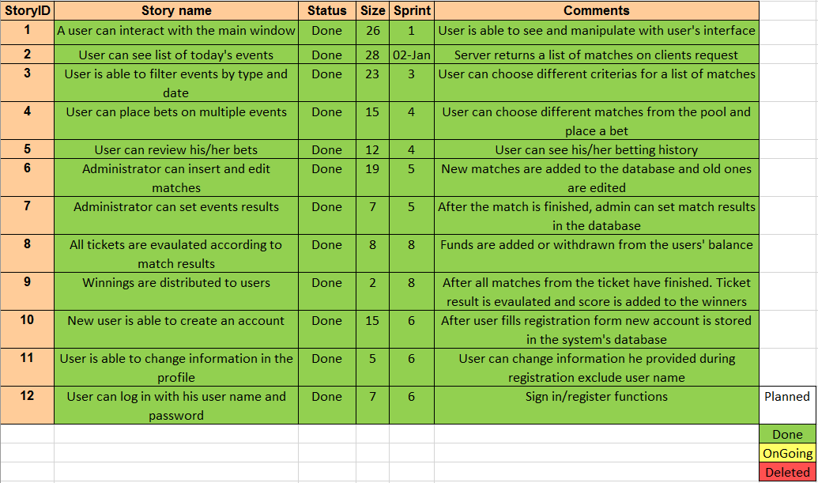
Figure 3. Final version of the product backlog

The next step of the development process, according to the SCRUM framework, was to determine the number of sprints as well as the size of each task in it and the total size of all the tasks. As can be seen from the image above, we ended up with 12 stories with each one having a number of several sub stories. In the following section, the reader can get familiar with the sprints and their assigned tasks.

2.1 Sprints

There were several factors that influenced our decision regarding the number of sprints and their individual sizes. One of the more important ones was the time limitation. We had to make an approximation for the size of each sprint so that it would be possible for all of them to be finished in time, even if unexpected errors occur and stories would have to be revisited and updated. After taking everything into account we ended up with 7 sprints and an average sprint size of 25 hours, well within the time frame specified in the project description. It is also important to note that each sprint is spread across two days, which makes the total time allotted for sprints equal to 14 days.

The main focus of the first sprint is the creation of a Client-Server connection and the main user interface – elements that lay the foundations of the program. The picture below shows the various sub stories and presents the reader with information about who is responsible for each story and what is its estimated size.

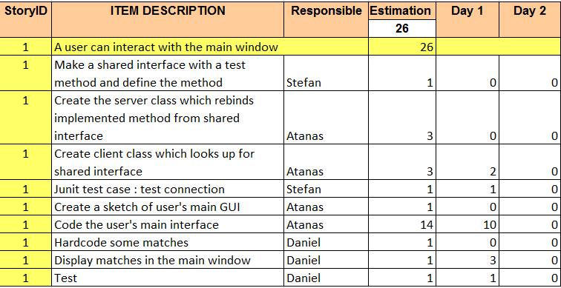
Figure 4. Sprint 1

The following sprint contains stories that continue to lay the foundations of the program. The main focus is the creation of a normalized relational database. Furthermore, connection to this database and Java is established in this sprint with defined methods for data extraction and insertion. Basically here we defined the bridge between the database and the java code. Apart from the database, the cardinal classes are also created in this sprint.

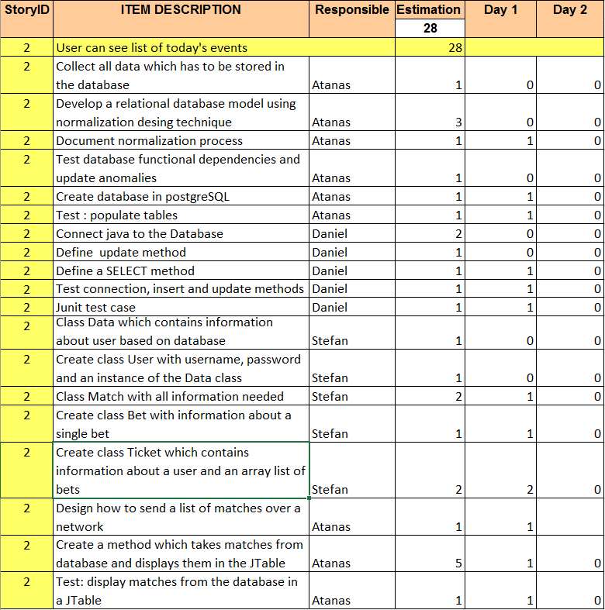
Figure 5. Sprint 2

The target in sprint 3 is the filtering function and what has to be implemented for it to be operational.

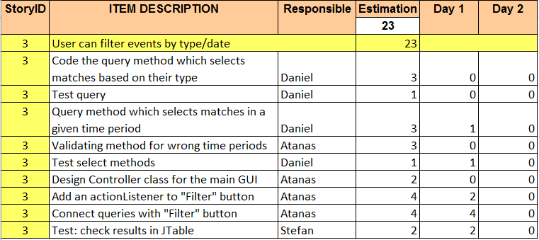
Figure 6. Sprint 3

Sprint 4 focuses on the main feature of the system that is placing a bet as well as reviewing your betting history. The big challenge during this sprint was to figure out how the user can add matches as well as make winner predictions for the same matches at the same time. After some discussions and different ideas about the design, we all agreed on the double clicking feature (for more information about the feature check the project report) which was approved by all team members and eventually included in the system.

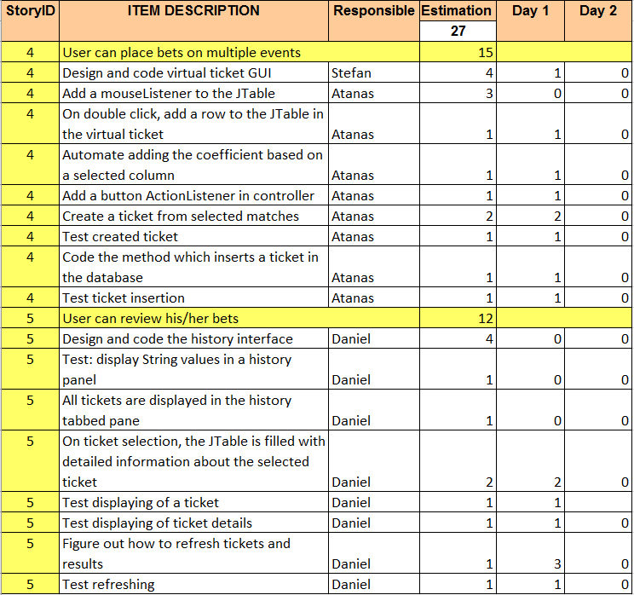
Figure 7. Sprint 4
In sprint 5, the team decided to put their efforts in developing the necessary functions and interfaces for the administrator side of the system. The interesting thing with the administrator is that he has an entirely different user interface, which means that an entirely different MVC module should be created for it. Another challenge from a design standpoint was how we could include the whole functionality for the admin in one frame without having to transfer the user to different windows and frames.

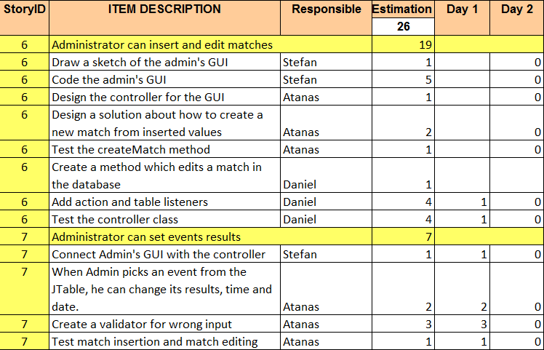
Figure 8. Sprint 5

Sprint 6 focuses on the user authentication process and the interaction with the database. There are also several stories, regarding the user interface, where the user enters the credentials necessary for login or registering.

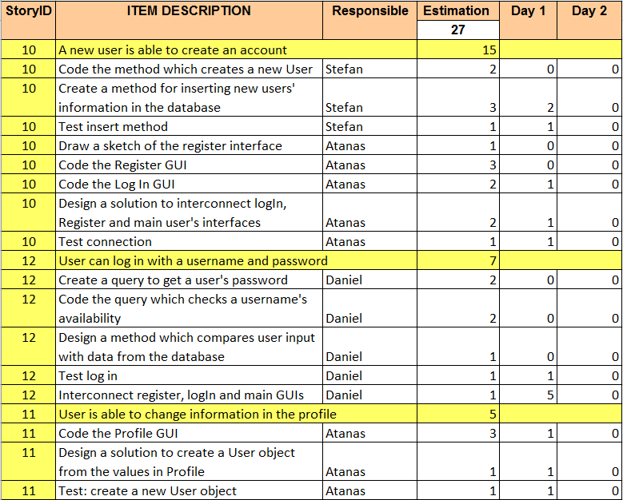
Figure 9. Sprint 6

The interesting thing about sprint 7 is that it was created from a meeting with the project’s supervisor. After the database, that was used at the time, was carefully inspected, we were advised to modify it. After estimations of the amount of work that has to be invested into it, we decided to create a new sprint with a size of 18 that would cover all the necessary changes for adapting the modified database with the code and vice versa.

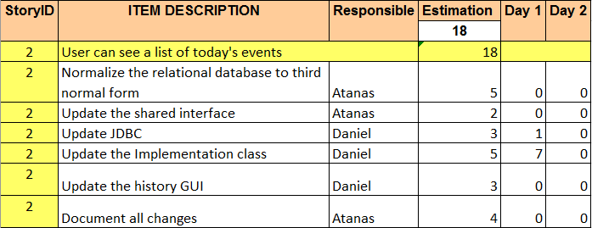
Figure 10. Sprint 7

The final sprint deals with ticket evaluation and the distribution of the winnings. The challenge for the team here is the algorithm for ticket status checks, and for the distribution of the winnings depending on the results.

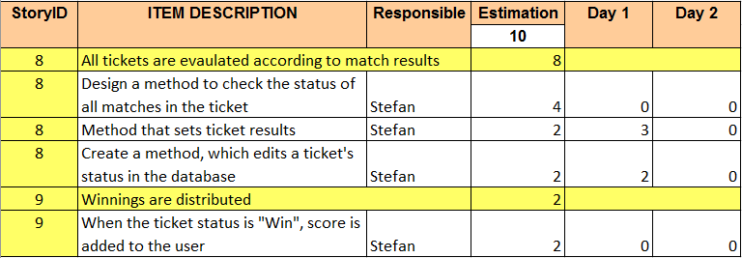
Figure 11. Sprint 8

This concludes the Sprints section.

With the start of the Construction phase, it was paramount for us to have an executable software module that would mark our progress after each sprint and give room for improvement or a complete revamp of a given feature, if necessary. After the end of each iteration, the team tested the newly created module as well as documented and reported any undesirable activities or inefficiencies of the software, so bugs and problems would be addressed on the spot rather than being left for fixing at a later stage, which would additionally overcomplicate the adjustment process later. Here it is important to note that Junit tests were created for the core functionalities, whereas the tests from a user standpoint occurred after we had developed the necessary user interfaces.

Test
Review and evaluate

Plan and Implement

In the course of the Transition phase, we took the roles of target users. After going through the several use cases over and over, we exchanged what results we had from the tests and discussed possible refinements that could be incorporated over the course of several Transition phase iterations. It is important to note that during this phase, after a meeting with the project’s supervisor, we established that a major database overhaul had to be done. Of course, the amount of work needed for this remodeling meant that we had to make another sprint only dedicated to the database change as well as its adaptation to the code. After that, we repeated our working cycle for the iteration and concluded the work in the last phase.

3. Meetings

Throughout the course of the project development, we had several meetings including two meetings with a supervisor. The main goal of the meetings was to review our work as well as to share any new ideas or aspects that might need to be altered. We had several types of meetings adopted from the frameworks we were using during development:

- Sprint planning

During those meetings, which we had before every sprint, the whole team gathered and planned each individual item in it. In these meetings we made estimations about the size of each story and about the size of the sprint as a whole.

- Stand-ups

In the time of the stand-ups, we quickly assessed the work done and what work followed. Those meetings took place before commencing work on the sprint the team was focused on and were helpful in that we were quickly informed about the status of the daily tasks as well as the sprint.

- Iteration reviews

Iteration reviews were paramount because after those reviews, we felt more relaxed about a given feature, given that we thoroughly reviewed it and tested it. It is important to acknowledge that whatever part of the program we ended up reviewing during those meetings, it had to be fully demonstrable which means that we are not only testing the main feature but also the other functions (sub stories) required for it to be fully operational.

- Supervisor meetings

Supervisor meetings proved to be extremely useful and important for the proper project development in the long run. We had two supervisor meetings in total during the creation of this project. Below is a brief description of the subjects discussed:

1st meeting: At the first meeting we cleared several uncertainties related to SCRUM and UP. The product backlog underwent several changes due to the supervisor’s guidance. An example of such a change is the first 5 stories in the backlog being rewritten as if they are from the user’s perspective. Here we would like to note that in this meeting was acknowledged the wrong design of our relational database. After careful scrutiny on the supervisor’s part, we had to alter the database and normalize it.

2nd meeting: The main theme of the second meeting was the feedback from the supervisor about the revamped database design. It took place after the added sprint, whose focus was addressing the relational database issues. The result of this meeting was that we had correctly followed the advice of the supervisor and the changes we had committed were acceptable. (For the interested reader, a comparison of the old and the current version of the relational database is available in the Appendix).

4. Project Result

As a team we believe that the SCRUM and UP frameworks were extremely beneficial and allowed us to follow a solid working strategy that does not restrict us to make changes but rather embraces them. The various meetings being held, initially considered tedious and unnecessary, actually boosted the team’s efficiency and encouraged us to adopt new working ethic values with the main focus being, sharing and cooperating. Furthermore, the evolution of the software we were creating with time, especially the changes that had to be made regarding the database, has shown us that there is always room for improvement. By doing SCRUM, the rate of things being overlooked was decreased dramatically compared to previous projects. This only serves as proof of the huge beneficial effect this framework provides. Even though we had to do a major overhaul of the database, thanks to the iterative nature of our working process and the exceptional time management, we succeeded in patching it by making only one additional sprint.
The burndown chart is a precise representation of the work done for the time allotted for the project:

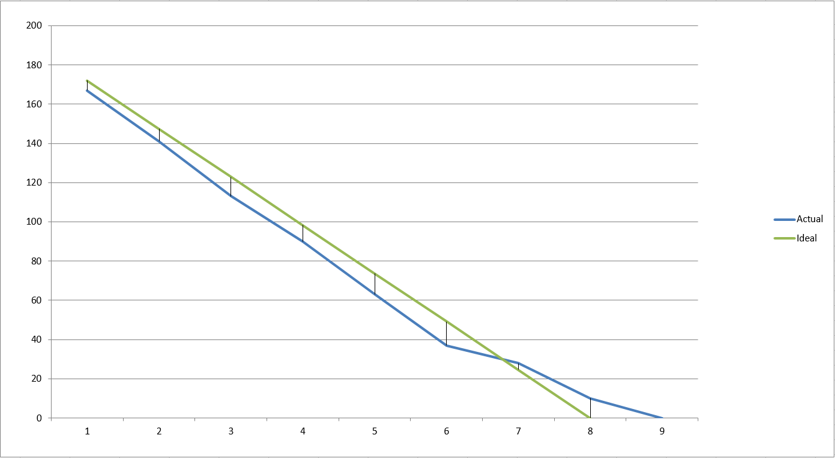
Figure 12. Betting system burndown chart
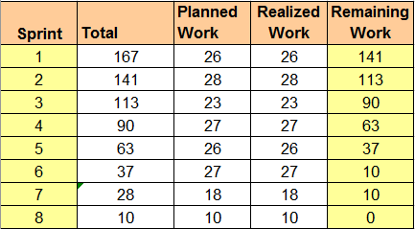
Figure 13. Work size

The burndown chart shows the team’s performance throughout the development process. The addition of the extra sprint and the work done related to the database remodeling, is clearly indicated by the end of the actual work remaining line.

Regarding future work improvements or things we would change, on the top of our list are the supervisor meetings and how they augment the end project result, since we experienced this effect during this task ourselves.
Another thing to consider for future projects is to properly evaluate and consider the risk factors of a project so if further problems occur, there is enough time to address them.

5. Personal reflections

Atanas Latinov:

The main requirements of this project, the first being a Client-Server system, and the second: to use a relational database, definitely added more depth to the project we had to make. A huge amount of the technologies that we used, were new to me and that made it more challenging, thus more interesting. The other engaging aspect of the project was work methodology and what strategies and methods we were going to follow in order to successfully create the product as well as satisfy the given requirements. Up until the beginning of the semester I had never heard of Unified Process or about the development framework that is SCRUM. Needless to say, I had to quickly bring myself up to speed in order to be able to enhance the entire team’s effectiveness and provide help when needed. I have to say that following those strategies gave me confidence that if we as a team continue to follow the guidelines and use the tools properly, we will have no problems creating and documenting the system in the given time, even if we are three people. Eventually it turned out as expected and even though we had to make an additional sprint and address the database issues, we still managed to complete everything before the deadline. What I gained from this project is definitely the importance of defining or using a robust working strategy. Good team work is not only great synergy between the team members. If you want to build a successful project, you have to be disciplined and follow a carefully devised set of rules and guidelines and SCRUM and UP definitely provided us with all that.

Daniel Hamarik:

During the second semester, we have been learning about collections, design patterns, client-server connection, databases, SCRUM as well as unified process. I am very glad that we did this project where we had a chance to apply all the theoretical knowledge we gained during the semester. We followed SCRUM as agile software development framework. From the beginning it was a bit chaotic but after a couple of iterations, I consider it as a very useful tool in system development. As a result of using scrum artefacts and ceremonies, our meetings were well structured and everybody knew what is going on. I really enjoyed all group meetings, since all of them were highly productive. However, if I could go back in time, I would change some things, because we work agile and we are always evolving as well as the system. I would definitely change RMI because of the connection issues and instead of it, use sockets. To summarize, I am really satisfied with our Betting system.

Stefan Aleksiev:
About my personal reflection on the semester project I can say that I learnt more about how to structure a big project, from where is the best point to start and more about working as a group. I think we did good work on the whole project and I can say that almost everything which was planned, was done on time, which is really satisfying for me. I hope our next semester project will be better.

